Machine Learning Fundamentals:
Data Collection -> Data preparation -> Selecting an appropriate algorithm -> Training the model on prepared data -> Evaluating its performance through testing and iteration
Training Data
ML process starts with collecting and processing training data.
Data directly proportional to performance of the model/ quality of the model
i.e. good data -> good performance of the model
bad data -> garbage in garbage out.
Types of data
- Labelled data
- Instance or examples have associated labels or target variables.
- Data consists of ip features along with corresponding op or classification.
- Unlabeled data
- Do not have.
- Only ip features.
- Structured data
- Data arranged in rows and columns or predefined manner or structure.\
- Traditional ml algorithms requires.
- Tabular Data -> spreadsheets, database, CSV files etc.
- Time Series Data -> stock prices, sensor readings, or weather data.
- Unstructured data
- Lacks structured or predefined format.
- Advanced ML algorithms or techniques are required to find the patterns.
- Such as text, audio, image, video.
- Text data -> documents, articles, social media posts etc.
- Image data -> images, photographs, videoframes etc.
ML Process
3 processes:
- Supervised Learning
- Unsupervised Learning
- Reinforcement Learning

Supervised Learning | Unsupervised Learning | Reinforcement Learning
In supervised learning, the algorithms are trained on labeled data.  The goal is to learn a mapping function that can predict the output for new, unseen input data. | Unsupervised learning refers to algorithms that learn from unlabeled data.  The goal is to discover inherent patterns, structures, or relationships within the input data. | In reinforcement learning, the machine is given only a performance score as guidance and semi-supervised learning, where only a portion of training data is labeled. Feedback is provided in the form of rewards or penalties for its actions, and the machine learns from this feedback to improve its decision-making over time.

Inferencing
After the model is trained, the process of using the information that a model has learned to make predictions or decision is called inferencing.
There are two types of inferencing.
- Batch inferencing.
In batch inferencing, the computer takes large amount of data and analyzes it all at once to provide the set of results.
Use case: When the speed of the decision-making process is not crucial.
- Real-time inferencing.
The computer has to process the incoming data and make the decision instantly.
Use case: When the computer has to make the decision very quickly in response to new information as it comes in.

Use Cases of ML
Supervised learning use case:
There are two types of supervised learning:
- Classification
Classification is used to assign labels or categories to new, unseen data instances based on a trained model. The model is trained on a labeled dataset, where each instances is already assigned to a known class or category.
The goal of classification is to learn pattern from the labeled training data and use them to predict the class or category for new unlabeled data instances.
Use Cases:
- Fraud detection
- Image classification
- Customer retention
- Diagnostics
- Regression
Used for predicting continuous or numerical values based on one or more input variable. It is used to model the relationship between a dependent variable ( the value to be predicted) and one or more independent variables ( the feature or inputs used for prediction).
Use cases:
- Advertising popularity prediction
- Weather forecasting
- Market forecasting
- Estimating life expectancy
- Population growth prediction

Unsupervised learning use cases:
Two types:
- Clustering
This kind of algorithm groups data into different clusters based on similar features or distances between the data point to better understand the attributes of a specific cluster.
- Customer segmentation
- Targeted marketing
- Recommended systems

- Dimensionality reduction
Used to reduce the number of features or dimensions in a dataset while preserving the most important information or patterns.
- Big data visualization
- Meaningful compression
- Structure discovery
- Feature elicitation

Deep Learning Fundamentals
It is inspired by the structure of human brain.
It consists of artificial neural networks just has human brain consists so it mimics the way the human brain processes the information.
Neural Networks
The core of DL is neural networks. Just like our brain that have neurons connected to each other, neural networks also have tiny units called nodes. The nodes are organized into layers. Such as:
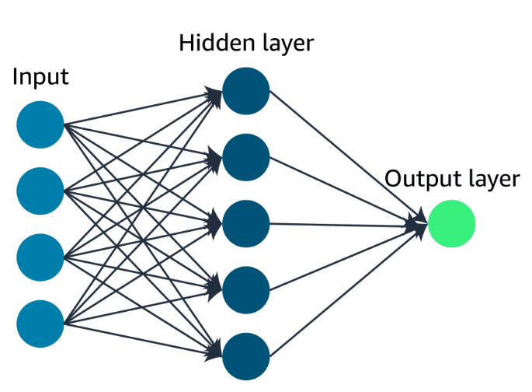
Input layer, one or more Hidden layers and Output Layer

The branches of AI where DL is used:
- Computer Vision
- It interprets and understands digital images and videos.
- Tasks are image classification, object detection, image segmentation etc.
- Natural Language Processing
- Deals with the interaction between computers and human languages.
- Tasks such as text classification, text generation, machine translation, sentiment analysis etc.

Generative AI
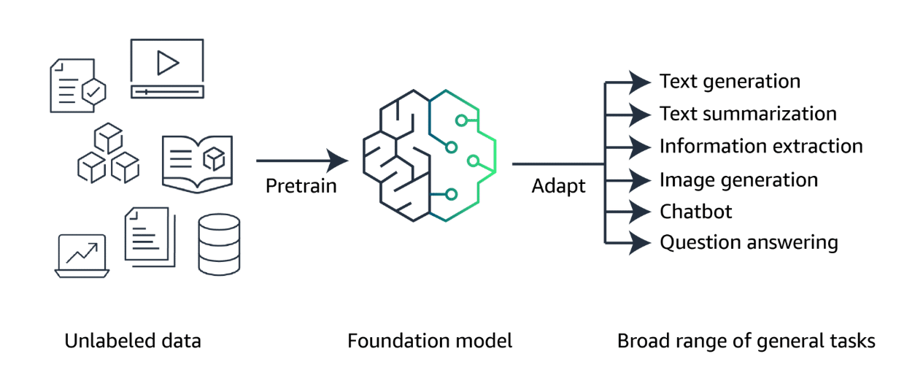
Foundation Models
Generative AI is powered by models that are pretrained on internet-scale data, and these models are called foundation models (FMs). With FMs, instead of gathering labeled data for each model and training multiple models as in traditional ML, you can adapt a single FM to perform multiple tasks. These tasks include text generation, text summarization, information extraction, image generation, chatbot interactions, and question answering. FMs can also serve as the starting point for developing more specialized models.
Lifecycle of Foundation Models:
      - Data Selection: Unlabeled data can be used at scale for pre-training because it is much easier to obtain compared to labeled data. Unlabeled data includes raw data, such as images, text files, or videos, with no meaningful informative labels to provide context. FMs require training on massive datasets from diverse sources.
      - Pre-training: Although traditional ML models rely on supervised, unsupervised, or reinforcement learning patterns, FMs are typically pre-trained through self-supervised learning. With self-supervised learning, labeled examples are not required. Self-supervised learning makes use of the structure within the data to autogenerate labels.
During the initial pre-training stage, the FM's algorithm can learn the meaning, context, and relationship of the words in the datasets. For example, the model might learn whether drink means beverage, the noun, or swallowing the liquid, the verb.
After the initial pre-training, the model can be further pre-trained on additional data. This is known as continuous pre-training. The goal is to expand the model's knowledge base and improve its ability to understand and generalize across different domains or tasks.
- Optimization: Pre-trained language models can be optimized through techniques like prompt engineering, retrieval-augmented generation (RAG), and fine-tuning on task-specific data. These methods will vary in complexity and cost.
- Evaluation: Whether or not you fine-tune a model or use a pre-trained model off the shelf, the next logical step is to evaluate the model. An FM's performance can be measured using appropriate metrics and benchmarks. Evaluation of model performance and its ability to meet business needs is important.
- Deployment: When the FM meets the desired performance criteria, it can be deployed in the target production environment. Deployment can involve integrating the model into applications, APIs, or other software systems.
- Feedback and Continuous Improvement: After deployment, the model's performance is continuously monitored, and feedback is collected from users, domain experts, or other stakeholders. This feedback, along with model monitoring data, is used to identify areas for improvement, detect potential biases or drift, and inform future iterations of the model. The feedback loop permits continuous enhancement of the foundation model through fine-tuning, continuous pre-training, or re-training, as needed.

Types of FMs:
Large Language Models (LLMs)
Large language models (LLMs) can be based on a variety of architectures, but the most common architecture in today's state-of-the-art models is the transformer architecture. Transformer-based LLMs are powerful models that can understand and generate human-like text. They are trained on vast amounts of text data from the internet, books, and other sources, and learn patterns and relationships between words and phrases.
Tokens:
Tokens are the basic units of text that the model processes. Tokens can be words, phrases, or individual characters like a period. Tokens also provide standardization of input data, which makes it easier for the model to process.
As an example, the sentence "A puppy is to dog as a kitten is to cat." might be broken up into the following tokens: “A” “puppy” “is” “to” “dog” “as” "a" “kitten” “is” “to” "cat."
Embedding and vectors:
Embeddings are numerical representations of tokens, where each token is assigned a vector (a list of numbers) that captures its meaning and relationships with other tokens. These vectors are learned during the training process and allow the model to understand the context and nuances of language.

For example, the embedding vector for the token "cat" might be close to the vectors for "feline" and "kitten" in the embedding space, indicating that they are semantically related. This way, the model can understand that "cat" is similar to "feline" and "kitten" without being explicitly programmed with those relationships.
Diffusion Models
Diffusion is a deep learning architecture system that starts with pure noise or random data. The models gradually add more and more meaningful information to this noise until they end up with a clear and coherent output, like an image or a piece of text. Diffusion models learn through a two-step process of forward diffusion and reverse diffusion.
Forward Diffusion:

Using forward diffusion, the system gradually introduces a small amount of noise to an input image until only the noise is left over.
Reverse Diffusion:
In the subsequent reverse diffusion step, the noisy image is gradually introduced to denoising until a new image is generated.

Multimodal models
Instead of just relying on a single type of input or output, like text or images, multimodal models can process and generate multiple modes of data simultaneously. For example, a multimodal model could take in an image and some text as input, and then generate a new image and a caption describing it as output.
These kinds of models learn how different modalities like images and text are connected and can influence each other. Multimodal models can be used for automating video captioning, creating graphics from text instructions, answering questions more intelligently by combining text and visual info, and even translating content while keeping relevant visuals.
Other generative models
Generative Adversarial Networks (GANs)
GANs are a type of generative model that involves two neural networks competing against each other in a zero-sum game framework. The two networks are generator and discriminator.
Generator: This network generates new synthetic data (for example, images, text, or audio) by taking random noise as input and transforming it into data that resembles the training data distribution.
Discriminator: This network takes real data from the training set and synthetic data generated by the generator as input. Its goal is to distinguish between the real and generated data.
During training, the generator tries to generate data that can fool the discriminator into thinking it's real, while the discriminator tries to correctly classify the real and generated data. This adversarial process continues until the generator produces data that is indistinguishable from the real data.
Variational Auto-encoders (VAEs)
VAEs are a type of generative model that combines ideas from autoencoders (a type of neural network) and variational inference (a technique from Bayesian statistics). In a VAE, the model consists of two parts:
Encoder: This neural network takes the input data (for example, an image) and maps it to a lower-dimensional latent space, which captures the essential features of the data.
Decoder: This neural network takes the latent representation from the encoder and generates a reconstruction of the original input data.
The key aspect of VAEs is that the latent space is encouraged to follow a specific probability distribution (usually a Gaussian distribution), which allows for generating new data by sampling from this latent space and passing the samples through the decoder.

Optimizing model outputs
A key part of the foundation model lifecycle is the optimization phase. An FM can be further optimized in several different ways. These techniques vary in complexity and cost, with the fastest and lowest cost option being prompt engineering.
Prompt engineering
Prompts act as instructions for foundation models. Prompt engineering focuses on developing, designing, and optimizing prompts to enhance the output of FMs for your needs. It gives you a way to guide the model's behavior to the outcomes that you want to achieve.
A prompt's form depends on the task that you are giving to a model. As you explore prompt engineering examples, you will review prompts containing some or all of the following elements:
Instructions: This is a task for the FM to do. It provides a task description or instruction for how the model should perform.
Context: This is external information to guide the model.
Input data: This is the input for which you want a response.
Output indicator: This is the output type or format.
The following is an example of a prompt that could be provided to a FM.
- Example prompt
You are an experienced journalist that excels at condensing long articles into concise summaries. Summarize the following text in 2–3 sentences.
Text: [Long article text goes here]
Fine-tuning
Although FMs are pre-trained through self-supervised learning and have inherent capability of understanding information, fine-tuning the FM base model can improve performance. Fine-tuning is a supervised learning process that involves taking a pre-trained model and adding specific, smaller datasets. Adding these narrower datasets modifies the weights of the data to better align with the task.
There are two ways to fine-tune a model:
Instruction fine-tuning uses examples of how the model should respond to a specific instruction. Prompt tuning is a type of instruction fine-tuning.
Reinforcement learning from human feedback (RLHF) provides human feedback data, resulting in a model that is better aligned with human preferences.
Consider this use case for fine-tuning. If you are working on a task that requires industry knowledge, you can take a pre-trained model and fine-tune the model with industry data. If the task involves medical research, for example, the pre-trained model can be fine-tuned with articles from medical journals to achieve more contextualized results.
Retrieval-augmented generation
Retrieval-augmented generation (RAG) is a technique that supplies domain-relevant data as context to produce responses based on that data. This technique is similar to fine-tuning. However, rather than having to fine-tune an FM with a small set of labeled examples, RAG retrieves a small set of relevant documents and uses that to provide context to answer the user prompt.
RAG will not change the weights of the foundation model, whereas fine-tuning will change model weights.

